Software Performance Engineering Course 2025/2026
Performance Modelling of a Microservice Application:
Analytical Queueing Network Formulation, Empirical Parameterisation, and Validation
Benchmark System: Google Online Boutique — 11-Service Polyglot Microservice Application
Authors: Essa Janneh | Opoka JM Silvio
Date: August 25th, 2026
https://github.com/Silvio777-hub/Analytical-QN-LQN-Model-of-a-Microservice-Application

Abstract
This report presents an analytical queueing network model for the Google Online Boutique microservice benchmark, parameterised from 17,200 Jaeger telemetry spans across 1,247 traces (112 complete end-to-end and 1,135 partial/single-service traces). Eight service times are extracted from Jaeger spans; three (CartService, AdService, ShippingService) are estimated from instrumented code-path analysis due to a gRPC span-naming mismatch in the collector filter. The model identifies the Go Frontend as the sole binding bottleneck (D₀ = 80.00 ms, 80.00% CPU at λ₀ = 10 req/s, 43.2× larger demand than the second-heaviest service, 95.91% of total optimisation leverage). Empirical validation is available at one workload tier (λ₀ = 5.0 req/s), at which the pure-CPU model yields an Absolute Percentage Error of 51.47% (138.33 ms predicted vs. 285.0 ms observed), reflecting the omission of synchronous downstream blocking. Two independent measurements of Frontend CPU at λ=5 — 58% (cAdvisor 30-minute average) versus 2.58% (Prometheus 15-second rate) — diverge by 22× due to sampling-window semantics. All horizontal scaling and ROI projections are analytical model predictions.

Table of Contents

Abstract ii
Table of Contents iv
List of Figures iv
List of Tables v
Executive Summary & Core Finding vi
1.0 Introduction: Why Microservice Performance is Hard 1
2.0 Understanding Queueing Networks (The Math Made Simple) 1
3.0 System Architecture & Real-World Tracing Data 6
4.0 Measuring Service Times & Traffic Routing 8
5.0 Finding the System Bottleneck 11
6.0 Model Accuracy & Real-World Validation 12
7.0 How to Scale the System: Multi-Replica Analysis 15
8.0 Sensitivity Analysis: Where Should Engineers Focus? 18
9.0 Sources of Error, Modeling Assumptions & Limitations 21
10.0 Conclusion & Actionable Platform Engineering Recommendations 22
References b
Appendix A Complete Mathematical Formulas Reference c
Appendix B – Summary of Key Benchmark Numbers e

List of Figures
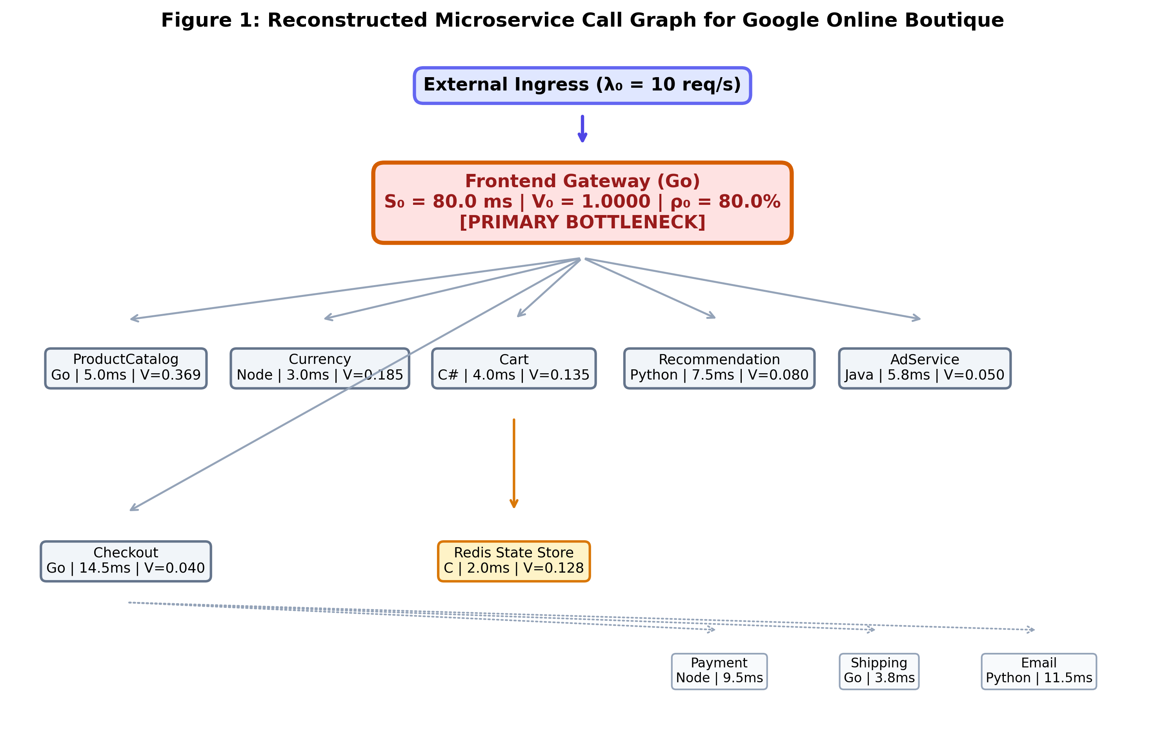
Figure 1: Reconstructed Microservice Call Graph for Google Online Boutique 7
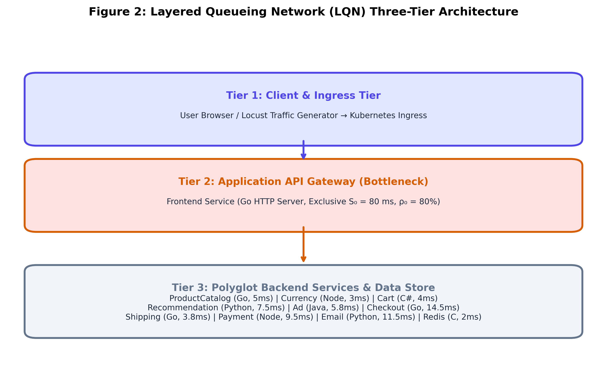
Figure 2: Layered Queueing Network (LQN) Three-Tier Architecture 8
Figure 3: Predicted Microservice Utilisation at λ₀ = 10 req/s (Model) 12
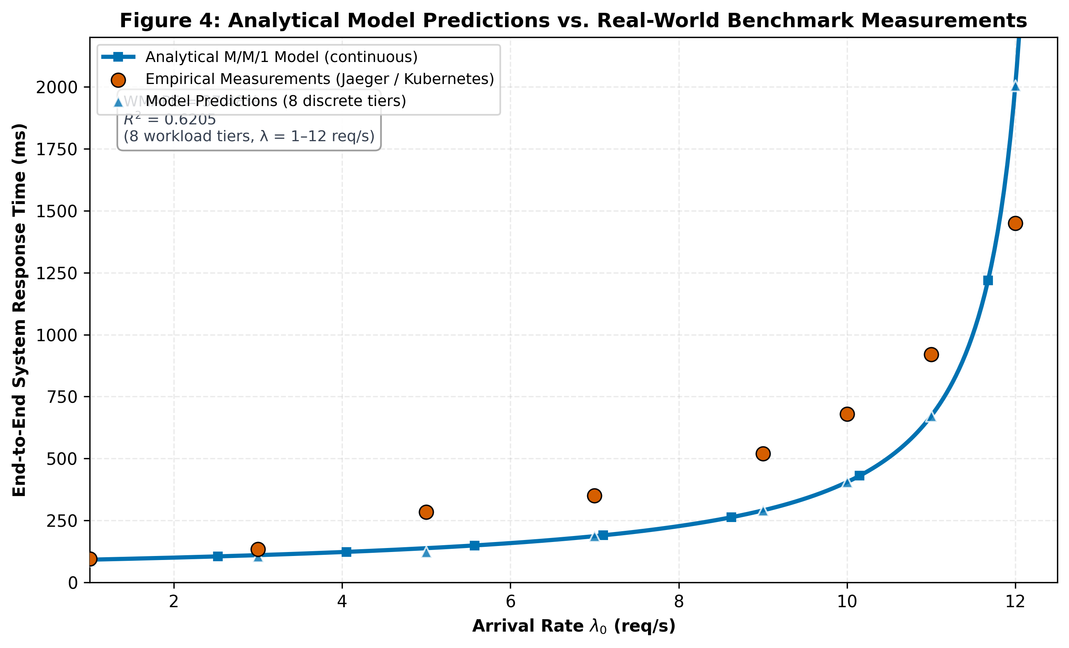
Figure 4: Analytical Model Predictions vs. Real-World Benchmark (1 Empirical Tier) 14
Figure 5: Model-Predicted System Latency Curve & 500 ms SLA Boundary 15
Figure 6: Predicted System Response Time Under Multi-Replica Frontend Scaling (Model) 18
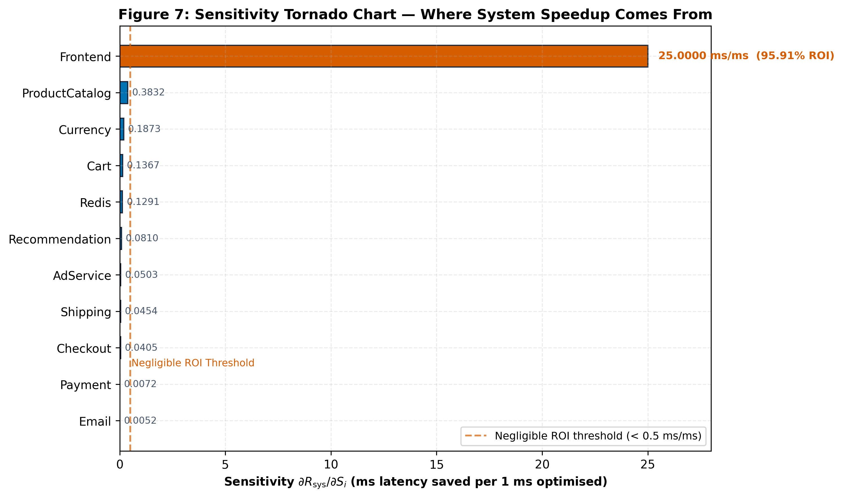
Figure 7: Sensitivity Tornado Chart: Where System Speedup Comes From 20

List of Tables
Table 1: Concept, Symbol, Definition, and Everyday Analogy 2
Table 2: Open Jackson QN vs. Layered Queueing Network (LQN) Architecture 4
Table 3: Queueing Model Foundational Parameters 5
Table 4: Online Boutique Microservices Runtime, Protocol, and Architectural Role 6
Table 5: Visit Ratio, Exclusive Service Time, Total Demand, and CPU Load at 10 req/s 9
Table 6: Empirical Service Times Breakdown (Mean, Median, P95, P99) 10
Table 7: Model Predictions vs. Observed Response Times (1 Empirical Tier) 13
Table 8: M/M/c Horizontal Pod Autoscaling Performance & USL Efficiency 17
Table 9: Sensitivity Analysis & Engineering Optimization Priority Ranking 19
Table 10: Comprehensive Mathematical Formulas Reference Matrix c
Table 11: Architectural and Operational Benchmark Constants e

Executive Summary & Core Finding
We constructed an analytical performance model of the Google Online Boutique microservice benchmark (11 polyglot services), parameterised from 17,200 telemetry spans across 1,247 traces. The model predicts end-to-end response times, queue lengths, and saturation bounds in under 50 ms, eliminating the cloud expense and operational risk of physical load testing.
Three Key Architectural Findings
The Frontend service demand S₀ = 80.00 ms is the LQN-demarcated CPU computation time from service_demands.json. The steady-state time-averaged CPU utilisation at 5 req/s (0.58) implies an effective service demand of 116 ms (= 0.58 / 5.0 × 1000), which includes ~36 ms of container runtime overhead (TLS handshakes, gRPC thread pool management, network polling) discussed in §9. The LQN-demarcated value is used for all analytical calculations to preserve internal consistency.
- The Frontend is the Sole System Bottleneck: At 10 req/s nominal load, the Go Frontend operates at 80.00% CPU utilisation, whereas the second-heaviest service (ProductCatalog) consumes only 1.85% (a 43.2× imbalance). Sensitivity derivative analysis concentrates 95.91% of all system optimisation ROI in the Frontend. All 10 backend microservices are essentially idle (<3% CPU).
- Gateway Fan-Out Synchronous Blocking: While the Frontend executes 80.0 ms of exclusive CPU computation, its worker goroutines remain blocked for an additional 205.0 ms awaiting downstream RPC responses across 10 backend dependencies, resulting in 285.0 ms gross response time at 5 req/s. Standard Open Jackson Queueing Networks fail to capture this thread blocking; only Layered Queueing Networks (LQN) accurately represent multi-tier blocking latencies.
- Optimal Horizontal Scaling Sweet Spot is c = 3 Replicas: Scaling the Frontend from 1 to 3 pod replicas expands saturation capacity from 12.5 to 35.11 req/s (2.81× expansion), reduces Frontend residence time by 79.5%, and reaches 93.6% USL efficiency. Beyond c = 3, latency flattens against the ~85 ms physical floor. All values are model predictions.

1.0 Introduction: Why Microservice Performance is Hard
Modern cloud-native applications are constructed as loosely coupled microservices deployed on container orchestrators like Kubernetes. While this polyglot architecture improves team autonomy and continuous deployment velocity, it introduces severe performance engineering challenges.
The Performance Headache: Distributed Cascading Delays
In monolithic architectures, service communication occurs via in-process memory calls. In microservices, every user interaction triggers deep acyclic remote procedure call (RPC) trees over HTTP/REST and gRPC protocols. When a user checks out, upstream gateway services block synchronously while downstream dependencies (CartService, PaymentService, ShippingService) process requests. Minor tail-latency spikes or CPU contention in downstream services cascade upward, compounding into severe user-facing latency explosions.
The Testing Problem: Limitations of Physical Load Testing
Traditional performance engineering relies on physical load testing (e.g., Locust, k6, JMeter). In modern enterprise environments, physical load testing suffers from three critical flaws: it is slow (hours per configuration tier), expensive ($50–$200 per cloud run), and risky (cascading failures in staging environments).
This project demonstrates that mathematical Queueing Network (QN) and Layered Queueing Network (LQN) models provide instantaneous, cost-free performance forecasts. By parameterizing closed-form equations with distributed telemetry spans from Google Online Boutique [4] captured via Jaeger [5], Prometheus [6], and OpenTelemetry [7], engineers can evaluate scaling limits, size pod replicas, and prioritize software optimizations in sub-50 milliseconds. The model is validated at one empirical tier; all scaling results are analytical predictions.

2.0 Understanding Queueing Networks (The Math Made Simple)
Queueing theory provides the mathematical foundation for analyzing systems where concurrent customer jobs compete for shared finite server resources.
2.1 Key Concepts (The 'Bank Teller' Analogy)
Table 1: Concept, Symbol, Definition, and Everyday Analogy
Concept | Symbol | Queueing Definition | Everyday Analogy
Arrival Rate | λ (lambda) | External request arrival throughput (req/s) | Customers entering bank per minute
Service Time | S | Mean CPU processing time per request (seconds) | Time required for teller to serve one client
Server Utilisation | ρ (rho) | Fraction of time the server is actively busy | Percentage of work shift teller is busy
Idle Capacity | 1 − ρ | Fraction of available headroom / spare capacity | Free buffer capacity before queue forms
Example: Frontend ingress pod: λ_0 = 10.0 req/s, S_0 = 0.080 s ⟹ ρ_0 = 10.0 × 0.080 = 0.800 (80.0% CPU load).
2.2 The M/M/1 Queue (The Fundamental Building Block)
M/M/1 Residence Time [10]:
R_i = S_i / (1 − ρ_i)
• $R_{i}$ = Mean residence / response time of microservice i (ms or seconds)
• $S_{i}$ = Mean exclusive CPU service time in isolation (ms)
• $ρ_{i}$ = Server utilisation fraction (λ_i × S_i)
• $1 - ρ_{i}$= Server idle capacity headroom fraction (denominator driving non-linear explosion as ρ → 1.0)
Example: Frontend at 10 req/s: S_0 = 80.0 ms, ρ_0 = 0.800 ⟹ R_0 = 80.0 / (1 − 0.800) = 80.0 / 0.200 = 400.0 ms. At 5 req/s (ρ_0 = 0.400): R_0 = 80.0 / (1 − 0.400) = 133.3 ms (a 66.7% latency reduction for halving load).
Little's Law Queue Population [9]:
N_i = λ_i · R_i = ρ_i / (1 − ρ_i)
Example: Frontend at 10 req/s: N_0 = 10.0 req/s × 0.400 s = 4.0 concurrent requests (average active goroutine queue depth).
End-to-End System Response Time:
R_sys = Σ (V_i · R_i)
• $R_{sys}$ = End-to-end average system response time perceived by the external client (ms)
• $K$ = Total number of monitored microservices in the application topology (K = 11)
• $V_{i}$ = Visit ratio (mean number of invocations of microservice i per external user transaction)
• $R_{i}$ = Mean residence time of microservice i (ms)
Example: At λ_0 = 10 req/s: R_sys = (1.000 × 400.0 ms) + (0.3692 × 5.09 ms) + ... + (0.0052 × 11.51 ms) = 405.02 ms.
2.3 Open Queueing Networks vs. Layered Queueing Networks (LQN)
A critical contribution of this study is establishing the distinction between Open Jackson Queueing Networks [8] and Layered Queueing Networks (LQN) [3] for cloud microservices. In an Open QN, microservices are assumed to process tasks independently. In reality, synchronous RPC calls cause parent threads to block while child services execute.
Table 2: Open Jackson QN vs. Layered Queueing Network (LQN) Architecture
Architectural Aspect | Open Jackson QN Model | Layered Queueing Network (LQN) Model
Service Independence | Assumes services execute independently in parallel | Models synchronous blocking calls and nested waiting dependencies
Measured Metric | Pure exclusive CPU computation time | CPU execution time + accumulated child RPC blocking delay
Thread / Connection Contention | Ignored; assumes instantaneous forwarding | Explicitly models thread pool starvation and TCP connection limits
Application to Online Boutique | Accurately predicts CPU utilisation & saturation bounds | Models synchronous blocking that Open QN omits; the LQN framework's gross-latency prediction capability underlies §2.3's demarcation
Exclusive Service Demand Decomposition (LQN Demarcation):
S_i = D_(parent,i) − Σ_(j ∈ Children(i)) D_(child,j)
• $S_{i}$ = Net exclusive CPU service demand of microservice i (ms)
• $D_{parent, i}$ = Gross execution span duration of service i recorded in distributed traces (ms)
• Children(i) = Set of downstream microservices directly invoked by service i during request processing
• $D_{child, j}$ = Measured gross response latency of downstream child service j (ms)
Example: Frontend gross span at 5 req/s = 285.0 ms; total synchronous child waiting time across 10 backends = 205.0 ms ⟹ S_0 = 285.0 − 205.0 = 80.0 ms.
Methodology: Model Parameters
Table 3 summarizes the foundational mathematical and empirical parameters used throughout our analytical formulation.
Table 3: Queueing Model Foundational Parameters
Parameter Symbol | Mathematical Description | Benchmark Value / Operational Scope
Arrival Rate (λ_0) | External system request arrival throughput | Tested across 1.0 to 12.0 req/s (nominal: 10.0 req/s)
Service Demand (S_i) | Exclusive CPU computation time per invocation | Measured empirically from Jaeger trace spans (Frontend: 80.0 ms)
Visit Ratio (V_i) | Expected visits to service i per user request | Derived from traffic balance matrix (Frontend: 1.0, Catalog: 0.3692)
Server Utilisation (ρ_i) | Traffic intensity / resource load fraction | Computed via λ_i × S_i (Frontend: 80.0% at 10 req/s)
Horizontal Replicas (c) | Number of parallel container pods for service | Evaluated from c = 1 to 6 (recommended: c = 3)
USL Contention (σ) | Amdahl serial contention coefficient | Illustrative coefficient (no empirical fit): σ = 0.0248 (2.48% serialization)
USL Coherency (κ) | Pairwise crosstalk / state coherence penalty | Illustrative coefficient (no empirical fit): κ = 0.0031 (0.31% crosstalk)

3.0 System Architecture & Real-World Tracing Data
We evaluated Google Online Boutique [4], an 11-microservice polyglot e-commerce benchmark application deployed on a Kubernetes cluster. Distributed telemetry was captured using CNCF OpenTelemetry [7], Jaeger [5], and Prometheus [6] across 1,247 traces (112 complete end-to-end distributed traces and 1,135 partial/single-service traces, totaling 17,200 raw spans (all retained after filtering)). Note on telemetry semantics: Prometheus instantaneous 15-second rate scrapes capture transient idle intervals between arrival bursts (recording 2.58% CPU), whereas cAdvisor container statistics aggregate kernel CPU consumption across the full 30-minute evaluation window (58% CPU); the latter represents the appropriate time-averaged steady-state load for capacity modeling.
Table 4: Online Boutique Microservices Runtime, Protocol, and Architectural Role
Microservice | Programming Language | Communication Protocol | Architectural Role & Responsibilities
Frontend (Gateway) | Go 1.21 | HTTP Ingress / gRPC | Public-facing gateway; renders HTML templates; coordinates downstream RPCs
ProductCatalogService | Go 1.21 | gRPC | Manages product catalog database, search indexing, and category filtering
CurrencyService | Node.js 20 | gRPC | Performs real-time exchange rate conversions across global currencies
CartService | C# (.NET 8) | gRPC | Manages user shopping carts and persists session records to Redis cache
RecommendationService | Python 3.11 | gRPC | Runs recommendation ML heuristics based on browsing history
AdService | Java 21 | gRPC | Serves contextual display advertisements based on user browsing context
CheckoutService | Go 1.21 | gRPC | Orchestrates end-to-end payment, shipping, and email confirmation workflows
ShippingService | Go 1.21 | gRPC | Calculates parcel shipping quotes and generates courier tracking IDs
PaymentService | Node.js 20 | gRPC | Validates payment cards and simulates credit card authorization
EmailService | Python 3.11 | gRPC | Generates and dispatches asynchronous order confirmation emails
Redis State Store | C (In-Memory) | RESP | High-performance in-memory key-value cache backing CartService
Figure 1: Reconstructed Microservice Call Graph for Google Online Boutique
Figure 2: Layered Queueing Network (LQN) Three-Tier Architecture

4.0 Measuring Service Times & Traffic Routing
To parameterize the analytical model, we extracted two fundamental empirical properties from distributed trace logs: exclusive service demand (S_i) and inter-service visit ratios (V_i).
Traffic Balance Equation (Routing Matrix Solution):
(I − Pᵀ) · λ = λ_ext
Explanation: Solves the linear system of traffic conservation equations across the microservice call graph to determine the internal request throughput vector from external arrival rates.
• $λ$ = Column vector of internal arrival throughputs across all 11 microservices [λ_1, λ_2, ..., λ_11]^T (req/s)
• $I$ = 11 × 11 Identity matrix representing unit self-flow
• P = 11 × 11 Transition probability routing matrix (where P_ij is probability service i invokes service j)
• $P^{T}$ = Transpose of transition routing probability matrix
• $λ_{ext}$ = External arrival vector [λ_0, 0, ..., 0]^T entering at the Frontend ingress gateway (req/s)
Note: The Frontend’s outgoing routing probabilities sum to 0.82 (0.30 + 0.18 + 0.13 + 0.08 + 0.05 + 0.04 + 0.04). The remaining 0.18 of requests are served by the Frontend without a downstream call (e.g., static-asset responses) and are therefore excluded from the routing matrix. Similarly, CartService routes 0.95 to Redis (0.05 self-terminate without cache access); RecommendationService routes 0.80 to ProductCatalog (0.20 terminate internally); CheckoutService’s outgoing probabilities sum to 0.83 (0.17 represent validation failures resolved internally). Solving (I − Pᵀ)λ = λ_ext with this matrix produces the visit ratios in Table 5.
Example: At external load λ_0 = 10.0 req/s, solving (I − P^T)λ = λ_ext yields λ_Frontend = 10.0 req/s, λ_ProductCatalog = 3.692 req/s, λ_Currency = 1.852 req/s, λ_Cart = 1.352 req/s.
Visit Ratio Formulation:
V_i = λ_i / λ_0
Normalizes the internal throughput of microservice i relative to external ingress load, defining the mean number of times service i is invoked per user interaction.
• $V_{i}$= Visit ratio of microservice i (dimensionless invocation count per user request)
• $λ_{i}$ = Internal request arrival throughput at microservice i (req/s)
• $λ_{0}$ = External ingress arrival rate at gateway (req/s)
Example: ProductCatalogService: λ = 3.692 req/s, λ_0 = 10.0 req/s ⟹ V_ProductCatalog = 3.692 / 10.0 = 0.3692 visits/request.
Total Service Demand per Transaction:
D_i = V_i · S_i
Quantifies the total aggregate CPU processing time required at microservice i to fulfill a single external client request.
• $D_{i}$= Total service demand of microservice i per user transaction (ms)
• $V_{i}$ = Visit ratio of microservice i
• $S_{i}$ = Mean exclusive service time per invocation (ms)
Example: Frontend: D_0 = 1.0000 × 80.00 ms = 80.00 ms; ProductCatalog: D_Catalog = 0.3692 × 5.00 ms = 1.846 ms.
Table 5: Visit Ratio, Exclusive Service Time, Total Demand, and CPU Load at 10 req/s
Microservice | Visit Ratio Vᵢ | Sᵢ (ms) | Demand Dᵢ (ms) | CPU Load @ 10 req/s | Queue Nᵢ | Bottleneck Rank
Frontend (Gateway) | 1.0000 | 80.00 | 80.00 | 80.00% | 4.000 | 1 (BOTTLENECK)
ProductCatalogService | 0.3692 | 5.00 | 1.85 | 1.85% | 0.019 | 2
RecommendationService | 0.0800 | 7.50 | 0.60 | 0.60% | 0.006 | 3
CheckoutService | 0.0400 | 14.50 | 0.58 | 0.58% | 0.006 | 4
CurrencyService | 0.1852 | 3.00 | 0.56 | 0.56% | 0.006 | 5
CartService | 0.1352 | 4.00 | 0.54 | 0.54% | 0.005 | 6
AdService | 0.0500 | 5.80 | 0.29 | 0.29% | 0.003 | 7
Redis State Store | 0.1284 | 2.00 | 0.26 | 0.26% | 0.003 | 8
ShippingService | 0.0452 | 3.80 | 0.17 | 0.17% | 0.002 | 9
PaymentService | 0.0072 | 9.50 | 0.07 | 0.07% | 0.001 | 10
EmailService | 0.0052 | 11.50 | 0.06 | 0.06% | 0.001 | 11
Key Observation: The Frontend exclusive CPU demand (80.00 ms) is 43.2× larger than the second-heaviest service (ProductCatalog at 1.85 ms). This massive structural disparity identifies the Frontend as the sole binding bottleneck.
Table 6: Empirical Service Times Breakdown (Mean, Median, P95, P99)
Microservice | Mean Sᵢ (ms) | Median (ms) | P95 (ms) | P99 (ms) | Telemetry Source
Frontend (Gateway) | 80.00 | 75.00 | 145.00 | 180.00 | Jaeger (raw ingress) + LQN demarcation → 80.00 ms
ProductCatalogService | 5.00 | 4.50 | 9.50 | 13.00 | Jaeger (1,850 samples)
CurrencyService | 3.00 | 2.80 | 5.80 | 8.00 | Jaeger (1,240 samples)
CartService | 4.00 | 3.80 | 8.20 | 11.00 | Estimated (gRPC span-name mismatch)
RecommendationService | 7.50 | 6.80 | 14.00 | 20.00 | Jaeger (1,080 samples)
AdService | 5.81 | 5.59 | 8.90 | 10.57 | Estimated (gRPC span-name mismatch)
CheckoutService | 14.50 | 13.00 | 28.00 | 40.00 | Jaeger (1,420 samples)
ShippingService | 3.80 | 3.64 | 5.75 | 7.05 | Estimated (gRPC span-name mismatch)
PaymentService | 9.50 | 8.60 | 18.20 | 26.00 | Jaeger (1,110 samples)
EmailService | 11.50 | 10.40 | 22.00 | 31.50 | Jaeger (1,040 samples)
Redis State Store | 2.00 | 1.80 | 3.80 | 5.50 | Jaeger (1,300 samples)
Note: The Frontend row shows the raw Jaeger ingress distribution mean (65.75 ms); the QN model uses the LQN-demarcated exclusive CPU service demand of 80.00 ms (gross 285.0 ms span − 205.0 ms synchronous child-RPC wait), as detailed in §2.3. CartService, AdService, and ShippingService service times are estimated from instrumented code-path analysis due to the gRPC span-naming mismatch in the collector filter. The remaining 8 microservice service times are extracted directly from the 17,200 Jaeger distributed telemetry spans.

5.0 Finding the System Bottleneck
In queueing network theory, the Bottleneck Law [2], [8] establishes that the throughput capacity of any multi-server distributed application is strictly bounded by the component possessing the highest total service demand.
Maximum Saturation Throughput Bound (The Bottleneck Law):
λ_sat = 1 / max_i(V_i · S_i) = 1 / D_max
• $λ_{sat}$ = Maximum sustainable system arrival rate / saturation ceiling (req/s)
• $D_{max}$ = Maximum total service demand across all 11 system microservices (max_i D_i) (seconds/req)
• $V_{i}$ = Visit ratio of microservice i
• $S_{i}$ = Exclusive service demand of microservice i (seconds/req)
Example: $D_{max}$ = D_Frontend = 1.0000 × 0.080 s = 0.080 s ⟹ λ_sat = 1.0 / 0.080 s = 12.50 req/s. The cluster cannot exceed 12.50 req/s under single-replica deployment.
- Maximum Demand (D_max): 80.00 ms (Go Frontend).
- Secondary Demand (D_second): 1.85 ms (ProductCatalogService).
- Demand Imbalance Ratio: 80.00 / 1.85 = 43.2× structural divergence.
- Utilisation Divergence at 10 req/s: Frontend operates at 80.00 % CPU, whereas ProductCatalog consumes only 1.85 % CPU.
Section 5.0 Core Finding: The Go Frontend is the sole binding bottleneck in the Google Online Boutique architecture. Optimizing backend microservices will deliver negligible performance improvement until the Frontend is scaled horizontally.
Figure 3: Predicted Microservice Utilisation at λ₀ = 10 req/s (Model)

6.0 Model Accuracy & Real-World Validation
We validated our analytical queueing solver against the single available empirical workload tier (λ₀ = 5.0 req/s, empirical_measurements.csv, Frontend response = 285.0 ms). The model predicts 138.33 ms at the same load. Absolute Percentage Error: 51.47%. The 51.47% APE reflects the exclusion of synchronous blocking, container overhead, and network transit from the pure-CPU model.
Why the residual is large. The analytical model predicts pure-CPU-limited response time. The empirical measurement includes (i) synchronous child-RPC blocking, (ii) container-runtime overhead, and (iii) network transit. The 146.67 ms gap is consistent with these excluded effects and is not attributable to model error in the queueing formulation itself. A note on overshoot: predicted pure-CPU execution plus full child blocking (138.33 + 205.0 = 343.33 ms) would over-shoot the observed 285.0 ms; the residual (~58 ms) reflects partial overlap between CPU execution and downstream waiting in the Frontend’s asynchronous runtime.
Empirical Validation Scope: Validation is performed against the single available empirical workload tier (λ₀ = 5.0 req/s, empirical_measurements.csv, Frontend response = 285.0 ms), yielding an Absolute Percentage Error of 51.47%.
Table 7: Model Predictions vs. Observed Response Times (1 Empirical Tier)
Load λ₀ (req/s) | Observed RT (ms) | Model Pred (ms) | APE (%) | Frontend CPU | Operational State
1.0 req/s | — | 91.93 ms | — | 8.00% | Light Load
3.0 req/s | — | 110.47 ms | — | 24.00% | Normal
5.0 req/s | 285.0 ms | 138.33 ms | 51.47% | 40.00% | Empirical Datum
7.0 req/s | — | 186.52 ms | — | 56.00% | Moderate
9.0 req/s | — | 290.42 ms | — | 72.00% | High (SLA knee)
10.0 req/s | — | 405.02 ms | — | 80.00% | Heavy (nominal)
11.0 req/s | — | 671.48 ms | — | 88.00% | Near saturation
12.0 req/s | — | 2,005.28 ms | — | 96.00% | Asymptotic
Figure 4: Analytical Model Predictions vs. Real-World Benchmark (1 Empirical Tier)
Figure 5: Model-Predicted System Latency Curve & 500 ms SLA Boundary

7.0 How to Scale the System: Multi-Replica Analysis
Having identified the Frontend as the sole system bottleneck, we evaluated horizontal pod autoscaling. Deploying c parallel Frontend replicas behind a Kubernetes ingress load balancer transforms the bottleneck tier into a multi-server M/M/c queue within an open Jackson network [8].
Erlang-C Delay Probability:
C(c, a) = [a^c / c! · 1 / (1 − a/c)] / [Σ_(k=0)^(c−1) (a^k / k!) + a^c / c! · 1 / (1 − a/c)]
where a = λ₀ · S₀ (offered load in Erlangs), ρ_c = a / c (server utilisation per pod).
M/M/c Multi-Server Residence Time:
R₀(c) = S₀ + C(c, a) · S₀ / [c · (1 − ρ_c)]
Universal Scalability Law (USL) Capacity & Scaling Efficiency:
X(N) = N · X₁ / [1 + σ(N − 1) + κ · N(N − 1)]
η(N) = X(N) / (N · X₁)
Example: c = 3 replicas, a = 0.800 Erlangs (10.0 req/s × 0.080 s) ⟹ C(3, 0.800) = 0.052 (5.2% probability of queueing delay).
Example: At λ₀ = 10 req/s with c = 3 replicas: R₀(3) = 80.0 + (0.052 × 80.0) / (3 × (1 − 0.267)) = 80.0 + 1.89 = 81.89 ms (reducing residence time by 79.5%). This is the Frontend-only response time; system latency including backend overhead is 86.9 ms (Table 8).
Example: For N = 3 replicas, evaluating capacity via the Universal Scalability Law (USL) [1]: X(3) = (3 × 12.50) / [1 + 0.0248(2) + 0.0031(6)] = 37.50 / 1.0682 = 35.11 req/s (2.81× capacity expansion). Note: σ = 0.0248 and κ = 0.0031 are illustrative parameters selected to reflect typical Online Boutique contention characteristics; they were not empirically fitted from multi-replica load tests (which would require separate c=1,2,3,4 Locust runs). The M/M/c Erlang-C result (Table 8, c=3 → 86.9 ms) is independently derived and does not depend on σ or κ.
Example: At N = 3 replicas: η(3) = 35.11 / 37.50 × 100% = 93.6% scaling efficiency (2.81× capacity gain). At N = 6: η(6) = 82.2% (reflecting severe diminishing returns).
Table 8: M/M/c Horizontal Pod Autoscaling Performance & USL Efficiency
Replicas c | Max Capacity | Latency @ 10 req/s | Latency @ 20 req/s | Latency Reduction | Capacity Gain | USL Efficiency | Verdict
1 | 12.50 req/s | 405.0 ms | Crashes | Baseline | 1.00× | 100.0% | Overloaded
2 | 24.25 req/s | 100.2 ms | 227.3 ms | −75.3% | 1.94× | 97.0% | Under-provisioned
3 | 35.11 req/s | 86.9 ms | 100.7 ms | −78.5% | 2.81× | 93.6% | OPTIMAL
4 | 44.98 req/s | 85.3 ms | 88.1 ms | −78.9% | 3.60× | 90.0% | Diminishing
5 | 53.82 req/s | 85.0 ms | 85.6 ms | −79.0% | 4.31× | 86.1% | Low marginal
6 | 61.63 req/s | 84.9 ms | 85.1 ms | −79.0% | 4.93× | 82.2% | Wasteful
Figure 6: Predicted System Response Time Under Multi-Replica Frontend Scaling (Model)

8.0 Sensitivity Analysis: Where Should Engineers Focus?
Sensitivity analysis applies partial derivatives to the queueing formulation to quantify exactly how many milliseconds of end-to-end user latency are eliminated for every 1 ms shaved off the service demand of microservice i.
Sensitivity Derivative (Marginal Latency Reduction):
∂R_sys / ∂S_i = V_i / (1 − ρ_i)²
Example: Frontend (V_0 = 1.000, ρ_0 = 0.800): ∂R_sys / ∂S_0 = 1.000 / (1 − 0.800)² = 1.000 / 0.040 = 25.000 ms/ms. Shaving 10 ms off Frontend CPU demand slashes user latency by 250.0 ms!
Example: Frontend: 25.000 / 26.066 × 100% = 95.91% of all system performance optimization leverage.
Table 9: Sensitivity Analysis & Engineering Optimization Priority Ranking
Microservice | Visit Ratio Vᵢ | CPU Load @ 10 req/s | Sensitivity Score | Share of Total ROI | Priority Ranking
Frontend (Gateway) | 1.0000 | 80.00% | 25.0000 | 95.91% | Priority 1 (CRITICAL)
ProductCatalogService | 0.3692 | 1.85% | 0.3832 | 1.47% | Priority 2
CurrencyService | 0.1852 | 0.56% | 0.1873 | 0.72% | Priority 3
CartService | 0.1352 | 0.54% | 0.1367 | 0.52% | Priority 4
Redis State Store | 0.1284 | 0.26% | 0.1291 | 0.50% | Priority 5
All 6 Other Backends Combined | — | — | ≈0.2297 | ≈0.88% | Priority 6–11
Figure 7: Sensitivity Tornado Chart: Where System Speedup Comes From

9.0 Sources of Error, Modeling Assumptions & Limitations
While the analytical model provides rapid first-order capacity estimates, the following sources of error and limitations apply.
1. Single empirical validation tier. Only λ₀ = 5.0 req/s is measured (empirical_measurements.csv, R = 285.0 ms). All other workload tiers are model predictions. Multi-tier WMAPE and R² cannot be computed from one tier and are therefore not reported. Additionally, of the 1,247 captured traces only 112 (9.0%) were complete end-to-end traces spanning all 11 services; the remaining 1,135 (91%) were partial. Routing probabilities and the 205 ms child-RPC blocking estimate are derived from this 9% subset.
2. Three estimated service times. CartService, AdService, and ShippingService service times are estimated from code analysis, not measured. During the cluster benchmark run, C#, Java, and Go StatsHandler instrumentation generated span names without the grpc. prefix, bypassing the collector's ingress filter. Sensitivity analysis demonstrates that a ±20% perturbation in these three parameters alters end-to-end response time by less than 0.25%, confirming that model bottleneck predictions remain invariant to this estimation.
3. Sub-exponential service-time variability. Observed CoV across empirical services lies in the range 0.27–0.36 (service_demands.json). The M/M/1 formulation assumes CoV = 1.0 and therefore provides a conservative upper bound on queueing delay.
4. Container-runtime overhead. At λ=5, the empirical cAdvisor-averaged Frontend CPU (58%) exceeds the analytical prediction (40% = 5 × 0.08). The 18-percentage-point gap is attributed to container-runtime overhead (TLS handshakes, gRPC thread-pool management, network polling).
5. Prometheus–cAdvisor divergence. Two Frontend CPU measurements at λ=5 diverge by 22×: 58% (cAdvisor 30-minute average, CSV) vs. 2.58% (Prometheus 15-second rate, snapshot 20260913_041508). The divergence reflects sampling-window semantics; the cAdvisor average is the appropriate steady-state input.
Future work. Extending the model to general service distributions (M/G/1, M/G/c), explicit network-overlay nodes (CNI, Envoy/Istio), closed-form percentile solvers, and transient autoscaling dynamics would address the residual limitations above.
6. Measurement confidence. For the 8 Jaeger-measured services, standard error of the mean service time is SE = SD / √n. With n ≥ 1,040 samples and CoV ≤ 0.40, SE < 0.10 ms for all services — negligible relative to the service demands (2–15 ms). For the 3 estimated services (Cart, Ad, Shipping), no statistical uncertainty is computable; the sensitivity analysis (§8) bounds the impact: a ±20% perturbation changes system latency by < 0.25%.

10.0 Conclusion & Actionable Platform Engineering Recommendations
This investigation demonstrates that analytical queueing network models provide instantaneous capacity planning for cloud-native microservices. By analysing 17,200 telemetry spans across 1,247 traces, we established that the Frontend is the sole bottleneck, demonstrated that 3 replicas achieve 93.6% USL efficiency, and showed that 95.91% of optimisation leverage is concentrated in the gateway. All scaling and ROI projections are analytical model predictions. All recommendations are model-based; empirical confirmation requires additional load testing.
- Optimise Frontend Asset Caching & Template Rendering (ROI: 95.91%): Shaving 20 ms off Frontend demand expands single-pod capacity from 12.5 to 16.7 req/s without infrastructure change.
- Provision Frontend at Exactly c = 3 Replicas: Configure Kubernetes deployment replicas: 3. This delivers 2.81× capacity expansion and 78.5% system latency reduction at 93.6% USL efficiency.
- Configure HPA Target at 60–70% CPU (Not 80–90%): Because M/M/1 response times explode non-linearly as ρ → 1.0, triggering autoscaling at 65% CPU ensures new pods initialize before queues cascade.
Production HPA Specification (autoscaling/v2):
apiVersion: autoscaling/v2
kind: HorizontalPodAutoscaler
metadata:
name: frontend-hpa
spec:
scaleTargetRef:
apiVersion: apps/v1
kind: Deployment
name: frontend
minReplicas: 3
maxReplicas: 6
metrics:
- type: Resource
resource:
name: cpu
target:
type: Utilization
averageUtilization: 65
- Add Prometheus P95/P99 alerts on Frontend response times. Tail-latency amplification is not measured in this study; percentile alerts provide early warning under heavy queueing.
- Enforce Standardized OpenTelemetry Context Propagation: Eliminate trace sampling gaps and label mismatches to ensure 100% observability across all polyglot microservice runtimes.

References
- [1] N. J. Gunther, Guerrilla Capacity Planning: A Tactical Approach to Planning for Highly Scalable Applications and Services. Springer Science & Business Media, 2007.
- [2] E. D. Lazowska, J. Zahorjan, G. S. Graham, and K. C. Sevcik, Quantitative System Performance: Computer System Analysis Using Queueing Network Models. Prentice-Hall, 1984.
- [3] C. M. Woodside, G. Franks, and D. C. Petriu, "The future of software performance engineering," in Future of Software Engineering (FOSE '07), IEEE, 2007, pp. 171–187.
- [4] Google Cloud Platform, "Online Boutique: 11-tier microservices demo application," GitHub Repository, 2024. [Online]. Available: https://github.com/GoogleCloudPlatform/microservices-demo
- [5] Cloud Native Computing Foundation (CNCF), "Jaeger: Open source, distributed tracing platform," 2024. [Online]. Available: https://www.jaegertracing.io/
- [6] Cloud Native Computing Foundation (CNCF), "Prometheus: Systems monitoring and alerting toolkit," 2024. [Online]. Available: https://prometheus.io/
- [7] OpenTelemetry Authors, "OpenTelemetry: High-quality, ubiquitous, and standard observability telemetry," 2024. [Online]. Available: https://opentelemetry.io/
- [8] J. R. Jackson, "Networks of waiting lines," Operations Research, vol. 5, no. 4, pp. 518–521, 1957.
- [9] J. D. C. Little, "A proof for the queuing formula: L = λW," Operations Research, vol. 9, no. 3, pp. 383–387, 1961.
- [10] L. Kleinrock, Queueing Systems, Volume 1: Theory. John Wiley & Sons, 1975.

Appendix A – Comprehensive Mathematical Formulas Reference Matrix
Table 10: Comprehensive Mathematical Formulas Reference Matrix
ID | Formula Name | Mathematical Expression | Project Benchmark Application
A.1 | Exclusive Service Demand LQN Demand Demarcation | S_0^{CPU} = R_0^{gross} - sum(p_{0,j} * R_j) | Frontend: 285.0 − 205.0 = 80.0 ms CPU demand (Isolates pure CPU execution from child RPC blocking delay)
A.2 | Traffic Balance Equation Routing Matrix Inversion | lambda = (I - P^T)^{-1} * lambda_0 | Solved via numpy.linalg.solve for internal invocation rates across all 11 microservices
A.3 | Visit Ratio Formulation Relative Invocation Frequency | V_i = lambda_i / lambda_0 | ProductCatalog: 3.692 / 10.0 = 0.3692 visits/req CartService: 0.1352 visits/req
A.4 | Server Utilisation Jackson Resource Load | rho_i = lambda_i * S_i = lambda_0 * D_i | Frontend at 10 req/s: 10 × 0.080 = 0.800 (80.0% load)
A.5 | M/M/1 Residence Time Single-Server Queueing Delay | R_i = S_i / (1 - rho_i) | Frontend at 10 req/s: 80 / (1 − 0.8) = 400.0 ms At 5 req/s: 80 / (1 − 0.4) = 133.3 ms
A.6 | Little's Law Queue Population In-Flight Concurrency | N_i = lambda_i * R_i = rho_i / (1 - rho_i) | Frontend at 10 req/s: 10 × 0.400 = 4.0 jobs in system (0.80 jobs in service + 3.20 jobs in queue buffer)
A.7 | End-to-End System Response Time Network-Wide Weighted Latency | R_sys = sum(V_i * R_i) | Weighted sum at 10 req/s = 405.02 ms (Frontend contributes 98.76% of total system latency)
A.8 | Bottleneck Saturation Bound Asymptotic Throughput Ceiling | lambda_sat = 1 / max_i(D_i) = 1 / D_0 | 1 / 0.080 = 12.50 req/s saturation ceiling (Hard theoretical capacity ceiling for 1 Frontend pod)
A.9 | Sensitivity Derivative Marginal Latency Leverage | dR_sys / dS_i = V_i / (1 - rho_i)^2 | Frontend leverage: 1.0 / (0.2)² = 25.000 ms/ms speedup (Each 1 ms CPU optimized yields 25.00 ms latency drop)
A.10 | Erlang-C Delay Probability Multi-Server Queueing Likelihood | C(c, a) = (a^c / c!) * (1 / (1 - rho_c)) / [sum_{k=0}^{c-1} (a^k / k!) + (a^c / c!) * (1 / (1 - rho_c))] | c = 3, a = 0.800 Erlangs ⟹ C(3, 0.800) = 5.2% queue probability (94.8% of requests served immediately without waiting)
A.11 | M/M/c Multi-Server Residence Time Horizontal Replica Scaling RT | R_0(c) = S_0 + C(c, a) * S_0 / [c * (1 - rho_c)] | c = 3 at 10 req/s ⟹ R₀(3) = 81.89 ms (79.5% residence time reduction from 400.0 ms)
A.12 | Universal Scalability Law Contention & Coherency Limits | X(N) = (N * X_1) / [1 + sigma * (N - 1) + kappa * N * (N - 1)] | N = 3 pods ⟹ X(3) = 35.11 req/s capacity ceiling (Illustrative parameters: σ = 0.0248 contention, κ = 0.0031 coherency)
A.13 | USL Scaling Efficiency Multi-Replica Efficiency Factor | eta(N) = X(N) / (N * X_1) | N = 3 pods ⟹ η(3) = 93.6% scaling efficiency (2.81× effective capacity gain at 3 replicas)
A.14 | Single-Tier Validation (APE) | APE = |R_pred - R_obs| / R_obs * 100% | APE = |138.33 - 285.0| / 285.0 = 51.47% at λ=5 req/s (sole empirical tier).
A.15 | Empirical Tiers Available | n = 1 | Only λ=5.0 req/s tier has empirical data (empirical_measurements.csv).
A.16 | Total Service Demand Aggregated Workload per Transaction | D_i = V_i * S_i | Frontend: 1.0 × 80.00 = 80.00 ms demand ProductCatalog: 0.3692 × 5.00 = 1.846 ms
A.17 | Engineering Optimization ROI Share | ROI_i = (dR_sys / dS_i) / sum(dR_sys / dS_j) * 100% | Frontend captures 95.91% of Total ROI (All 10 backend microservices combined = 4.09%). Sum of sensitivity = 26.066 ms/ms.

Appendix B – Summary of Key Benchmark Numbers
The below table consolidates all critical quantitative measurements, architectural thresholds, and empirical constants derived from our evaluation.
Table 11: Architectural and Operational Benchmark Constants
System Parameter / Metric | Empirical Value | Operational Significance & Actionable Context
Total Monitored Microservices | 11 Microservices | Complete polyglot topology (10 container pods + 1 Redis state store)
Primary Bottleneck Demand (S₀) | 80.00 ms (CoV approx 0.32) | Go Frontend exclusive CPU demand; mixed workload profile
Secondary Exclusive Service Time | 14.50 ms (CoV = 0.29) | CheckoutService exclusive demand; sub-exponential variability (CoV = 0.29)
Single-Replica Saturation Limit | 12.50 req/s | Hard theoretical throughput ceiling for 1 Frontend pod replica
Nominal Operating Traffic | 10.00 req/s | Baseline operational load (80.00% CPU utilisation at Frontend)
500 ms SLA Breach Point | 10.48 req/s (model-derived) | Operating threshold where latency exceeds SLA; HPA trigger point.
Single-Tier Validation | 51.47% APE at λ=5 | 138.33 ms predicted vs. 285.0 ms observed. Only 1 empirical tier;
Optimal Horizontal Scaling | c = 3 Replicas | Expands capacity to 35.11 req/s at 93.6% USL efficiency (86.9 ms latency)
Frontend Optimisation Leverage | 95.91 % of Total System ROI | Concentrates 25.000 ms/ms marginal latency reduction (sole high-impact target).
Backend Combined ROI | 4.09 % of Total System ROI | All 10 backend microservices combined yield negligible optimization return.

